Hello everyone,

I wanted to explore Stock Market Price Prediction, so I chose a relevant activity/project in this field.

Dataset: <https://www.kaggle.com/datasets/camnugent/sandp500?resource=download>

Objective: The objective of this activity is to forecast stock prices using historical data. I aimed to develop accurate and reliable forecasts for future stock prices by utilizing various time series forecasting techniques and models.

I began by running multiple models to determine the most suitable one for forecasting. Firstly, I loaded and preprocessed the data. Then, I plotted ACF and PACF plots to identify potential models for Time Series Modelling. I observed a decreasing trend in the ACF plot.

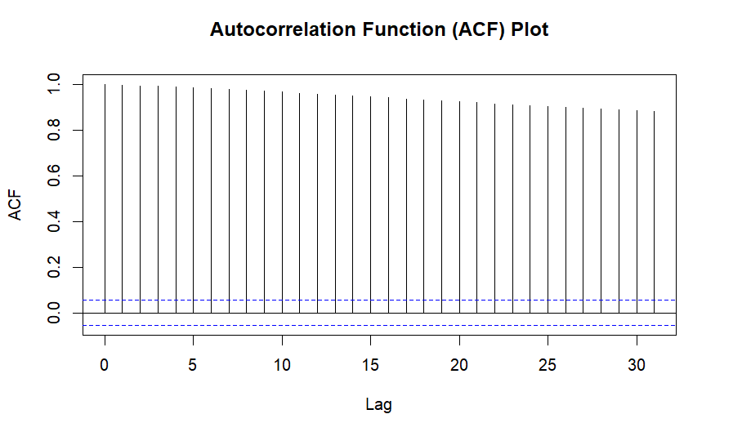

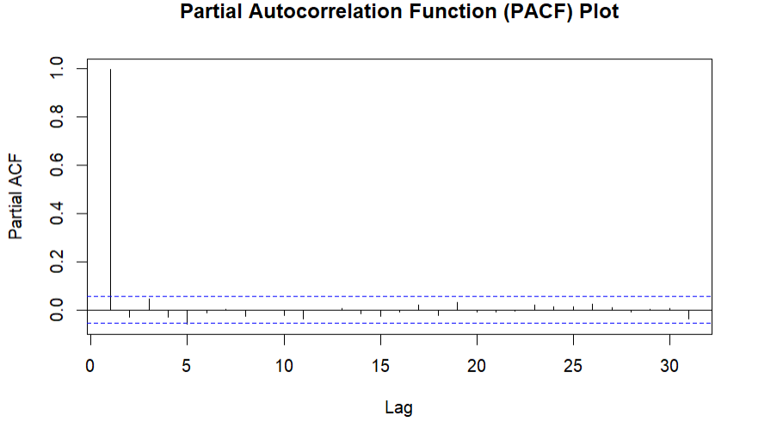

I consulted ChatGPT to help me select an appropriate model for the uploaded dataset. It provided a comprehensive list of models, including exponential smoothing, ARIMA, SARIMA, and Holt Linear, among others.

To make it more straightforward, I requested R code for Simple Exponential Smoothing (SES), ARIMA, and Holt Linear models. Following ChatGPT's suggestion, I used an ARIMA(1,0,1) model.

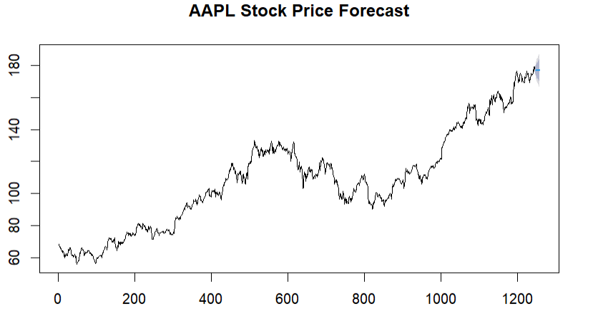

Upon comparing the MAE, MSE, and RMSE of each model, the ARIMA model performed reasonably well on the training set, exhibiting relatively low errors and a good fit. However, the inability to generate accurate forecasts for the test set raises concerns about the model's ability to generalize to unseen data.

The ARIMA model demonstrated slightly better performance than the Holt Linear model, while the SES model performed the poorest, as expected.